# Project Overview

|  |  |
| --- | --- |
| **Git Repo** | https://github.com/sameshar/CalTech_Course2_EndProject_SamerSharma.git |
| **Branch** | Master |

**Database details:**

|  |  |
| --- | --- |
| Database Name | Zumba |
| Table # 1 | Participants |
| Table # 2 | Batch |

**Screenshots:**

Homepage 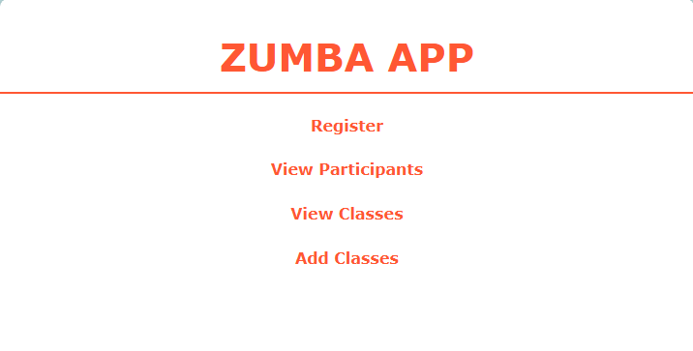

View list of all participants:

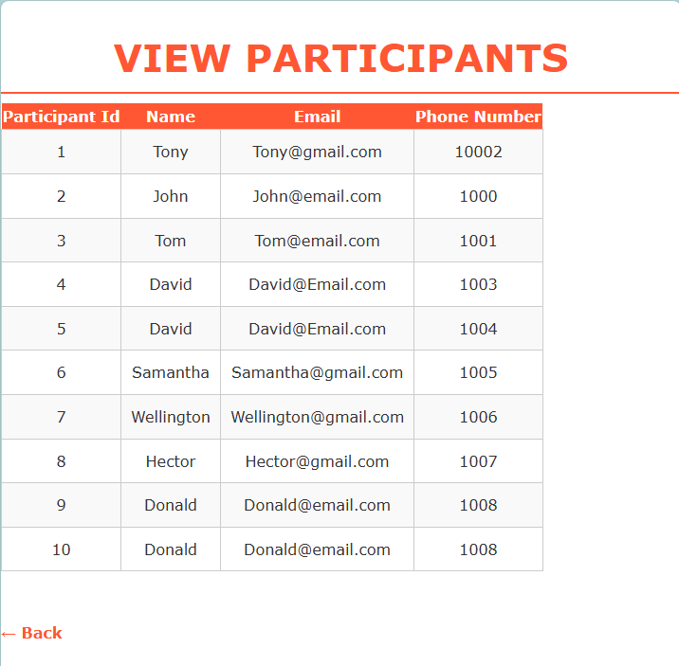

Register web page to add new participants:

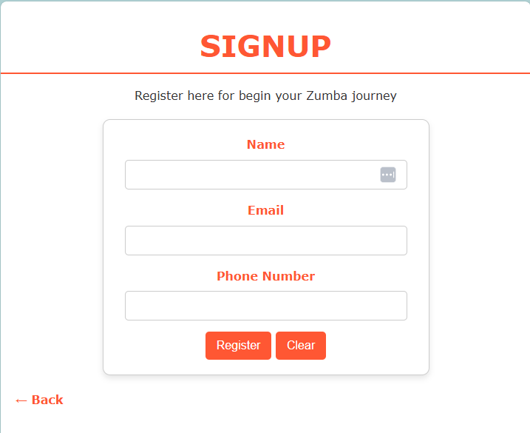

Add Batch to create new batches:

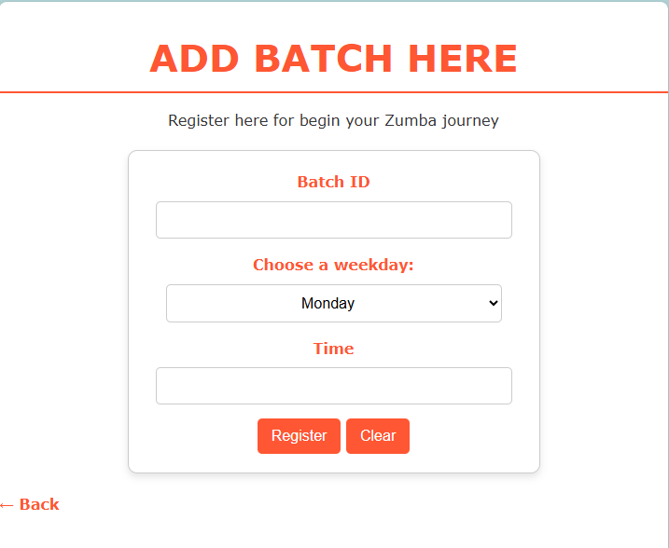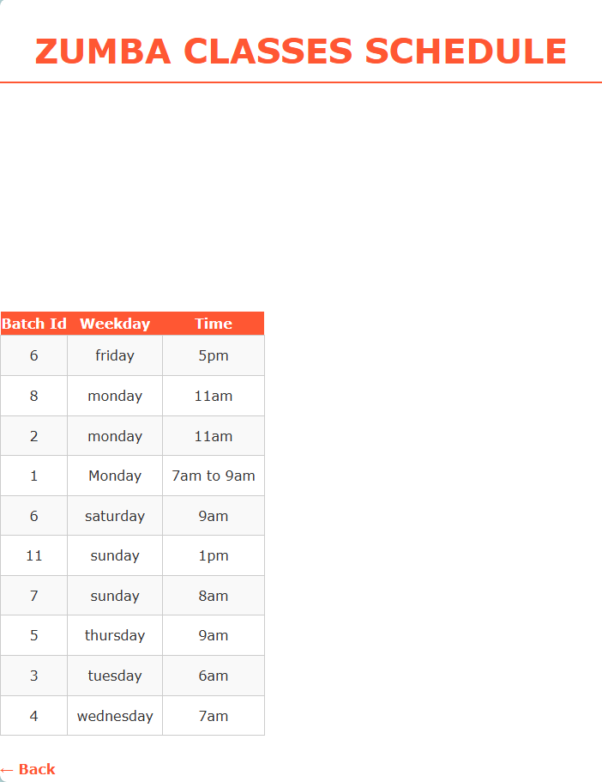

View batches:

Database screenshots:

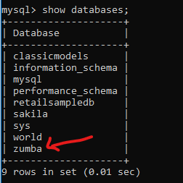

Show tables in Zumba database.

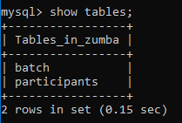

Details of Batch table

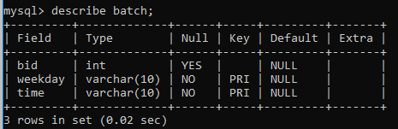

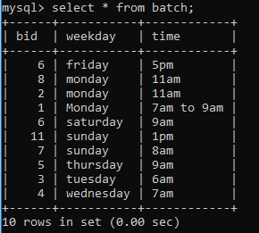Results of Batch table

Details of Participant tables

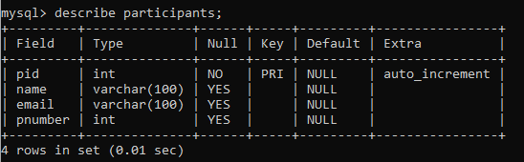

Results of Batch table

